Chapter 7 Data Types

Focus on what, why, when, where, etc.

What is data type - the meaning of ‘type’ (7.1.3)

Three approaches to the definition
- The denotational approach - a type is a collection of values from a "domain" (based on denotational semantics), type=domain
  - A value has the given type if it belongs to the set
  - An object has the given type if its value is guaranteed to be in the set
  - Ad: support user-defined composite types in terms of math op
- The constructor’s approach – data types are either
- Built-in (integer, real, char, etc), also called primitive, predefined
- Composite: constructed from built-in types, ex., record,
- The abstraction approach – an interface consisting of a collection of well-defined operations that can be applied to objects of that type

Why use data type? (What purpose does it serve?)

We need to know what kind of value is stored there, specifically:
- Provide implicit context for many operations.
- Allows type checking.
- Limit the set of operations that may be performed
  - Ex., char+struct is not allowed (type clash), but char+int might be OK
  - type checking cannot prevent all meaningless operations, however,
It catches enough of them to be useful.
  - How much error a language catches often speaks about how strong typed a language is

Strong(ly) Typed Language
- Prevents you from applying an operation to data on which it is not appropriate
- Almost always detect errors
  - strong = rigid
  - weak = flexible

Static Typed (a related concept)
- compiler can do all the checking (and hopefully, can catch most of the errors).

Strong type tends to imply static type, but not always
Ex., python,
- dynamic – type declaration not required:
Bob=1
Rob=2:
Bob=”name”
- strong
Bob+Rob → error
Examples:
- Ada is statically typed, and strong.
- Pascal is almost statically typed, pretty strong.
- Java is strongly typed, with a non-trivial mix of things that can be checked statically and things that have to be checked dynamically
- C is static and weak typed, ex.,
char *p;
*p = *(p+10)+10; // accepted. P[0] = p[10]+10;

- Python is dynamically-typed yet strong.

A type system (7.1) consists of
- A mechanism for defining types and associate them with certain language construct
- Rules for type equivalence, compatibility, and inference.

Some common terms (matching)

- Scalar (or simple) types - each value is a single object, contrast with composite.
  - There may or may not be order
  - Ex., real has order, complex odes not.

- Ordinal types – there is an order of all objects in the type.
Ex., int, float
- Discrete types – subset of ordinal, defined for isolated set of points (i.e., you can specify what come next), thus can have one-to-one mapping to integers.
  - integer
  - boolean
  - char
  - enumeration
  - subrange

- Composite types:
- record (union)
- array
  - string
- set
- pointer
- list
- file

7.2 Type Checking
The process of ensuring a program obeys language’s type compatibility. It uses rules of the type system to determine:
- type equivalence (when and if two values are of the same type) – more restrictive , but easier to implement
- type compatibility (when can a value of type A be used in a context that expects type B?)
  - Compatibility could be more useful concept, because it tells you what you can do
These terms are often (incorrectly, but we do it too) used interchangeably.

- type clash (a violation of the type system rules)

Type equivalence - two major approaches:
- Name equivalence:
  - same named type
  - based on declarations
    - What about aliasing? Ex.,
typedef Atype Btype;
// define Btype as Atype, which is user-defined, are they considered
// same type (ex., in C++?) Yes
// see TypeEquivalence.cpp

- Structural equivalence: Two types are the same if they consist of the same components, put together in the same way.
  - depends on simple comparison of type descriptions substitute out all names expand all the way to built-in types
  - Original types are equivalent if the expanded type descriptions are the same
  - format does not matter, ex.,
struct A{ int a, b; }
// is the same as
struct B{
int c, d;
}
// and
struct C{
int d;
int e;
}

Is structural equivalence a good measure?

Consider:
// type student
struct student
{
string name, address;
date bdate;
}

// type school
struct school
{
string name, address;
date bdate;
}

Should we allow student data to be copied to school data object? no

Type Compatibility
- Most languages do not require type equivalence in all operations.
- Operation involves data of different (but compatible) types often requires coercion

Coercion - implicit type conversion
- When an expression of one type is used in a context where a different type is expected, one may or may not get a type error. Ex.,

Var a : integer; b, c : real;
...
c := a + b;

- Many languages allow things like this, and COERCE an expression to be of the proper type

- Coercion can be based just on types of operands, or can take into account expected type from surrounding context as well

Ex., int a, b; float c;

c =a/b; // this / is going to be int division

- C has lots of coercion, but with simpler rules:

- all floats in expressions become doubles
- short int and char become int in expressions
- if necessary, precision is removed when assigning into LHS

- Languages such as Modula-2 and Ada do not permit coercions → strongly typed

Note the difference between coercion (i.e., implicit type conversion) and explicit type conversion
- type conversions are explicit (also called casting )
ex.,
c = a/float(b); // c++ casting, float /, or
c = a / (float) b; // old c casting
- type coercions are implicit

7.3 Records (ex., struct) and Variants (ex., unions)

Records
- usually laid out contiguously in memory
- possible holes for alignment reasons
- smart compilers may re-arrange fields to minimize holes
- implementation problems are caused by records containing dynamic arrays

Unions (variant records)
- overlay space
- cause problems for type checking
- Not as safe
  - Lack of tag means you don't know what is there

Memory layout and its impact (structures)

struct element
{
char name[2];
int atomic_number;
double atomic_weight;
bool metallic;
}

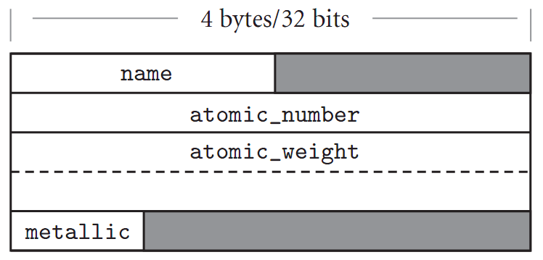
Figure 7.1 Likely layout in memory for objects of type element on a 32-bit machine. Alignment restrictions lead to the shaded “holes.”

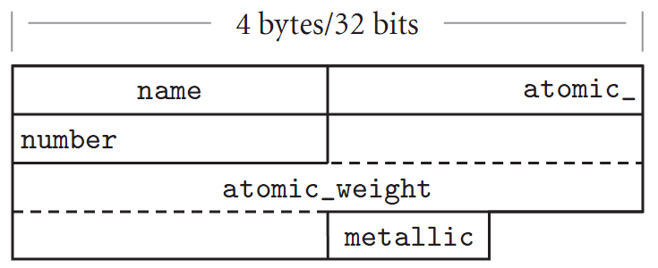
Figure 7.2 Likely memory layout for packed element records (ex., pascal). The atomic_number and atomic_weight ﬁelds are nonaligned, and can only be read or written (on most machines) via multi-instruction sequences.

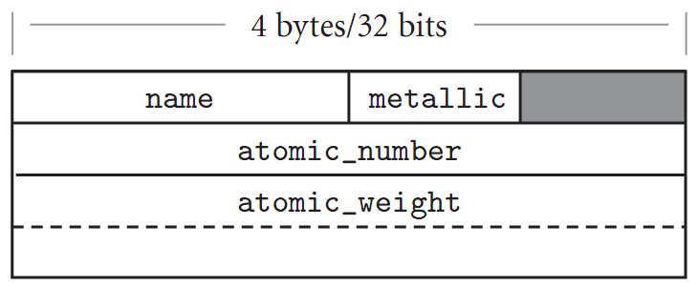
Figure 7.3 Rearranging record ﬁelds to minimize holes. By sorting ﬁelds according to the size of their alignment constraint, a compiler can minimize the space devoted to holes, while keeping the ﬁelds aligned.

Variant (or union) - two or more fields (source and lifetime) share the same space (see also union.cpp)

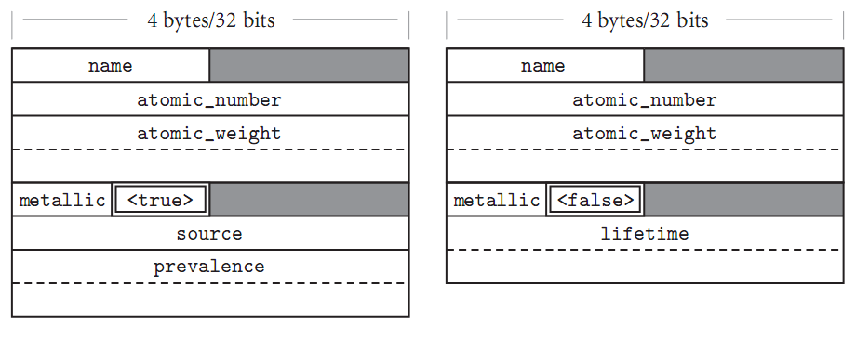
Figure 7.15 (CD) Likely memory layouts for element variants. The value of the naturally occurring ﬁeld (shown here with a double border) determines which of the

See also unions.cpp

7.4 Arrays
- the most common and important composite data types
- Unlike records, arrays are usually homogeneous
- Semantically, array is a mapping from an index type to a component or element type
- A slice or section: a segment (rectangular portion) of an 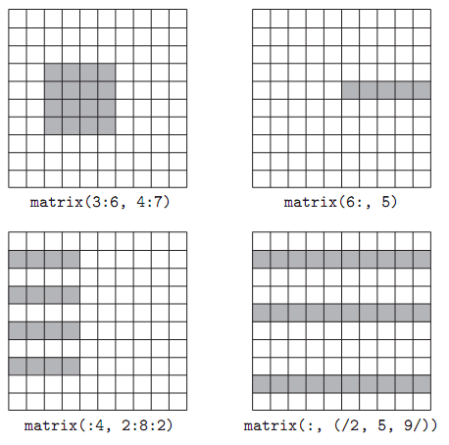
Figure 7.4 Array slices (sections) in Fortran90. Much like the values in the header of an enumeration-controlled loop (Section6.5.1), a: b: c in a subscript indicates positions a, a+c, a+2c, ...through b. If a or b is omitted, the corresponding bound of the array is assumed. If c is omitted, 1 is assumed. It is even possible to use negative values of c in order to select positions in reverse order. The slashes in the second subscript of the lower right example delimit an explicit list of positions.

    - Dimensions, Bounds, and Allocation of Array

Several types of array resulting in different allocations:
- global lifetime, static shape (global or static array, statically allocated)
  - the shape of an array is known at compile time
  - the array can exist throughout the execution of the program, thus
  - the compiler can allocate space for the array in static global memory

- local lifetime, static shape (ex., most C++ local, statically allocated array )
  - the shape of the array is known at compile time, but
  - the array would not exist throughout the execution of the program, and consequently,
  - space can only be allocated in the subroutine’s stack frame at run time.

- local lifetime, shape bound at elaboration time
  - local array dynamically allocated,
  - usually allocated on heap

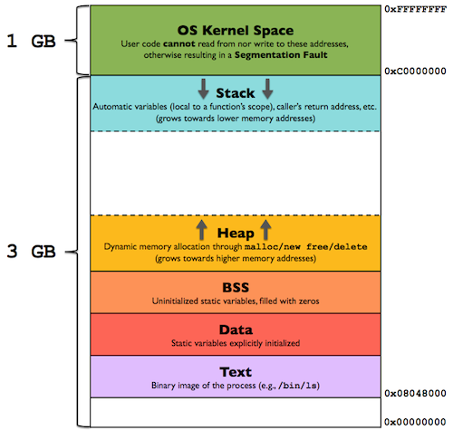

Example of program (process) memory layout
- text – code segment,
- Data – global & static variables, user initialized,
- BSS (What does it stand for?) – global & static variables, initialize (to 0) by system

Two layout strategies for arrays (Figure 7.8):
- Contiguous elements
  - Most common
- Row pointers
  - an option in C, ex.,
int **A;
…
See also 2dArray#.cpp
  - allows rows to be put anywhere - nice for big arrays on machines with segmentation problems
  - nice for matrices whose rows are of different lengths
    - e.g. an array of strings
  - requires extra space for the pointers

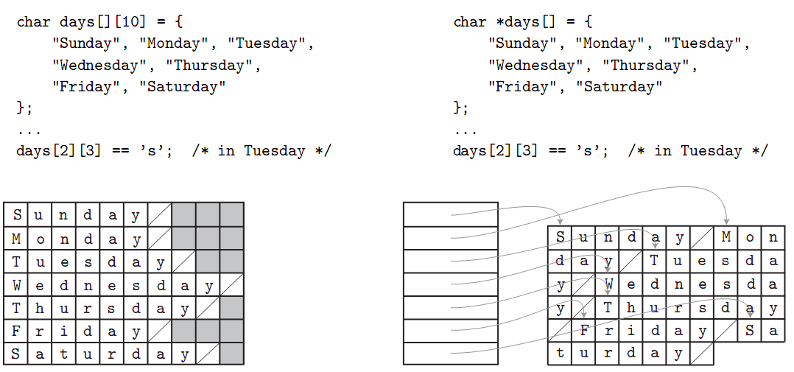

Figure 7.8 Contiguous array allocation v. row pointers in C. The declaration on the left is a true two-dimensional array. The slashed boxes are NUL bytes; the shaded areas are holes. The declaration on the right is a ragged array of pointers to arrays of character s. In both cases, we have omitted bounds in the declaration that can be deduced from the size of the initializer (aggregate). Both data structures permit individual characters to be accessed using double subscripts, but the memory layout (and corresponding address arithmetic) is quite different.

More about allocation of contiguous elements - ordering of allocation in 1D memory
(see also Figure 7.7)
- column major - only in Fortran

Order of sequential access of matrix should match the storing order of the matrix for efficiency.

Fortran stores 2D array in column-major order

DO 10 C = 1,300000
DO 5 R = 1,400000
SUM = SUM + A(R, C)
- CONTINUE
- CONTINUE

- row major – most languages
Ex., Content of array
A | B | C
D | E | F
G | H | I
J | K | L

Storing order
row major: A, B, … L
column major: A D G J B E H K C F I L

Address calculation (assuming lower bound of index is 0):

address(any element) = address(1st element) +offset

1D array of size M:

offset for A[K] = k*elementSize

2D array of size M rows and N columns stored with row major order

offset for A[J][K] = J*N*elementSize // total size of rows from 0 to J-1
+K*elementSize // total size of elements in row J columns 0 to K-1
= (J*N* +K)*elementSize

N-Dimensional array A[D₁] [D₂] [D₃] … [D_{N}] where D_{i} is the size of dimension i.

Offset for A[I₁] [I₂] [I₃] … [I_{N}] =

7.7 Pointers and Reference Types
Basics:
- Values of pointer types are memory addresses.
- A special value, NULL (or nullptr with value 0), is used to indicate that a variable does not contain a valid memory address.
- Used for indirect addressing and dynamic memory management.
- Pointers are used to access locations in an area where storage is dynamically allocated, ex., heap.
- Heap-dynamic variables are variables that are allocated from the heap. They are also called anonymous variables because they can only be accessed through pointers.
- First introduced in PL/1

Pointer Operations
Assignment – the pointer variable gets an address.

Design issue 1 – What value will be used when a pointer variable appears in an expression?
- Normal reference – C, C++, PASCAL
- The value of the pointer variable (i.e., address) is used.
- An extra symbol must be used for indirect referencing (i.e., referencing the value in the location to which the pointer points)
// C++ example
int *p, *q, j;
struct ty
{
int d;
} *r;
q = p+1; // q gets p’s value + 1, which is an address.
j = *p; // (indirect reference)
j = (*r).d; // j gets d’s value, which is a field of a record pointed to by r
j = r->d; // j gets d’s value.

{ Pascal example }
Type
Ty = record
d: integer;
end; { of record }
Var
R : ^Ty;
P,Q : ^integer;
J : integer;
Q := P; { Q gets P’s value, which is an address }
J := R^.d; { J gets d’s value. }

- Automatic Dereferencing – the value of the location pointed to by the pointer will be used automatically. No extra symbol needed for indirect referencing.
For example: in ADA, R.D refer to field D of a record R points to.
Java: Automatic Dereferencing for all user defined objects?

Pointer Problems
- Dangling pointer – a pointer that contains the address of a heap-dynamic variable that has been de-allocated. This is often the result of aliasing. For example:
float *p1, *p2;
p1 = new float;
p2 = p1;
delete p1;
p1=nullptr; // what’s the consequence if we skip this step?
// P2 is now a dangling pointer

- Lost Heap-Dynamic Variable (also called garbage, memory leak) - a heap variable that is no longer accessible to the user program. For example:
p1 = new float;
p1 = q; // what was *p1 is now garbage
void f ()
{
int *p;
p = new int[100000];
…..

//delete [] p; // omission of the delete statement will cause these 1000 integer cells
// to become garbage, a situation referred to as memory leakage.
// p = nulltpr; // this prevent UAF
}

Pointers in C and C++
- Extremely flexible, interesting, and dangerous.
- * denotes dereferencing.
- & denotes the address of a variable, ex.,
int j, *p;
p = &j;
- Pointer arithmetic is also possible, for example:
int s[10], *p;
p = s; // p points to beginning of s. s[0]
p += 5; // p now points to s[5];
(*p)++; // what does this do?
*p++ = 2; // what does this do?

Pointers in Pascal and ADA
- Pointer arithmetic is not allowed!
- Pointers can only point to heap locations
- Support explicit allocation and de-allocation, for example:
new, and dispose in PASCAL
uncheck_deallocation in ADA
- Heap dynamic variables in ADA are automatically initialized to null, and (b) de-allocated when the pointer variable go out of scope (i.e., terminates). Nice!

Reference Types
In C++:
- A special pointer type for defining formal arguments. For example:
void f (int & n); // n is a pointer to an integer,
// it is automatically dereferenced
In Java:
- All objects are reference type and implicitly de-allocated.

Implementation
- Pointers and Java reference types are stored in heap.
- Pointers are represented by 2 16-bit words representing two parts of an address: segment and offset.
- C++ reference argument are stored either on stack or heap, depending on the actual parameters used in the function call

Two methods for memory management in heap
- Single-size cells – all cells have the same size and are connected with a pointer field, forming a linked list of cells. (Used by most Lisp interpreter)

Two methods for memory de-allocation:
- Reference counter (also called the eager approach) – maintain a counter for each cell. The counter indicates the number of pointers currently pointing to the cell.
Return the cell to the available list when counter=0.

Is a cell guaranteed to be in use if counter>0?

Problems:
- Use too much extra space, especially when the cell itself is small.
- Require extra work whenever a pointer variable changes value:
Decrement the old counter and increment the new counter.
- Cannot easily handle circular references of cells.

- Garbage collection (a type of lazy approach) – collection is started when there is no more cell available, and is done in 2 phases:
- Traverse through the heap from each pointer of the program and mark all reachable cells.
- Return all unmarked cells to the list of available cells – these are no longer accessible from the program.

- Variable-size Cells

Methods still work, more effort:

garbage collection
- Phases I and II are not efficient because the indicators are not at the same location within the cells.
Possible solution: each cell begins with a cell-size field.

General problem:
- As blocks of cells are allocated and de-allocated, they become more and more fragmentation.

